Name of Student: Akshit Kumar | PRN:25070122270
Semester: III | Year : AY 2026-27
Subject: Programming with Java
ASSIGNMENT No : 12
TITLE : User-Defined Packages
Problem Statement
Write a Java program to create and use user-defined packages.
Learning Objectives
To create and use user-defined packages for organizing Java programs.

Programme
- Create a Java program by developing user-defined packages for a College Management System. Create separate packages for student and faculty details, and display their information using classes from these packages.
Student.java :
package student;
public class Student {
public void displayStudent() {
System.out.println("Student Name: Akshit");
System.out.println("Course: B.TECH");
System.out.println("Roll No: 270");
}
}
Faculty.java :
package faculty;

public class Faculty {
public void displayFaculty() {
System.out.println("Faculty Name: Amit Sharma");
System.out.println("Department: Computer Science");
System.out.println("Faculty ID: F101");
}
}
CollegeManagement.java :
import student.Student;
import faculty.Faculty;

public class CollegeManagement {
public static void main(String[] args) {
Student s = new Student();
Faculty f = new Faculty();

System.out.println("Student Details");
s.displayStudent();

System.out.println();

System.out.println("Faculty Details");
f.displayFaculty();
}
}

- Create a Java program by developing a user-defined package named library that contains a class to store and display book details such as book ID, title, author, and price. Import the package into the main program and display the book information.
Book.java
package library;

public class Book {

int bookId;
String title;
String author;
double price;

public Book(int bookId, String title, String author, double price) {
this.bookId = bookId;
this.title = title;
this.author = author;
this.price = price;
}

public void displayBook() {
System.out.println("Book ID: " + bookId);
System.out.println("Title: " + title);
System.out.println("Author: " + author);
System.out.println("Price: " + price);
}
}
LibraryDemo.java
import library.Book;

public class LibraryDemo {

public static void main(String[] args) {

Book b = new Book(
101,
"Java Programming",
"James Gosling",
550.0
);

System.out.println("----- Book Details -----");
b.displayBook();
}
}
Output
1)
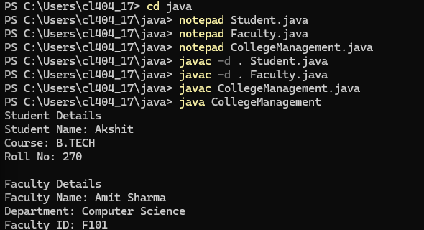
2)
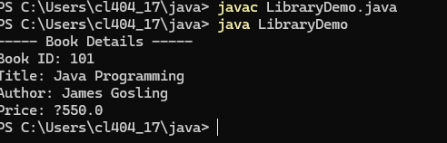
Conclusion
Thus we have successfully created and used user-defined packages for organizing Java programs

